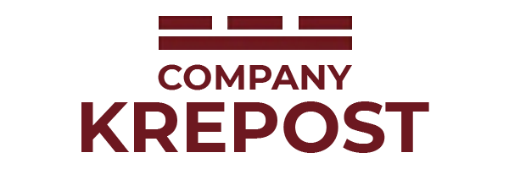
Limited liability company «Krepost»

ITN 3528197713, TRRC 352801001, PSRN 11335228000528

Address: Vologda region, Cherepovets city,

Komarova 10 street, office № 36, tel/fax 8 (8202)20-14-76
e-mail: krepost-stroi@mail.ru 8-953-501-02-28

Business proposal
LLC “Krepost” company offers wide range of services in subcontracting works (electric-welding, assembling and locksmith works).
LLC “Krepost” company has resource of qualified stuff and equipment for service (we have great experience in works with technological equipment of chemical plants).
Company source has specialist’s stuff:
№ | Profession | Quantity of specialists
1 | Electric-welder NAWC (manual-arch, manual-argon welding, mechanical powder wire welding in gas and mixtures) | 77
2 | Installer (T\P, MSS) | 117
3 | Technicians and engineers (foreman, head of sector) | 27
Total: 221 persons
LLC “Krepost” company works at industrial companies’ territory all over Russian Federation and CIS countries. Our specialists are ready efficiently come to your plant and execute “turkey” works of any complication. Also, our company works at stop-major repairs in chemical plants shops.
We are specialized at welding and assembling works on technical equipment, pipelines, and gas lines.
- Any welding types.
- Certified welding equipment
- Certified welding technology
- Specialists have valid certification of National Agency of welding control (NAWC).
“Krepost” company stuff consists of professionals, who are executing their tasks at metal steel structures, including non-standard metal steel structures performance.

Sincerely yours, LLC “Krepost” General Director,
Bogolubova Julia ph.n. +7 (953) 501-02-28

